**Ex. No.: 4**

**Date: 12.03.24**

**SIGNAL CATCHING**

**Aim:**

To write a C program to catch signals used in Linux.

**Program Code:**

// signals.c

#include <signal.h>

#include <stdio.h>

void my_handler (int sig); /* function prototype */

int main()

{

struct sigaction my_action;

/* Part I: Catch SIGINT */

my_action.sa_handler = my_handler;

my_action.sa_flags = SA_RESTART;

sigaction (SIGINT, &my_action, NULL);

printf ("Catching SIGINT\n");

sleep (3);

printf (" No SIGINT within 3 seconds\n");

/* Part II: Ignore SIGINT */

my_action.sa_handler = SIG_IGN;

my_action.sa_flags = SA_RESTART;

sigaction (SIGINT, &my_action, NULL);

printf ("Ignoring SIGINT\n");

sleep (3);

printf (" Sleep is over\n");

/* Part III: Default action for SIGINT */

my_action.sa_handler = SIG_DFL;

my_action.sa_flags = SA_RESTART; sigaction (SIGINT, &my_action, NULL); sleep (3);

printf ("No SIGINT within 3 seconds\n"); }

void my_handler (int sig)

{

printf (" \t I got SIGINT, number %d\n", sig); exit(0);

}

**Output:**

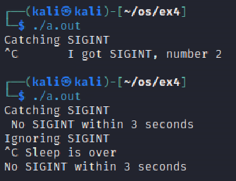

**Result:**

The above program executed successfully and output got verified.